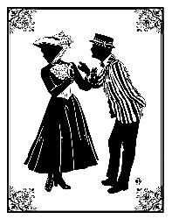
Just a Candygram of Sugar! Happy Valentine’s Day!
Money raised will support the 6th grade play.
Candygrams are $.50 each. Return form to Rm.12 or 13. You MUST provide your name for the treat to be delivered.

To: ________________________________________Room #______________
From: __________________________________________________________

Message: _______________________________________________________
_______________________________________________________

Valentine, You’re Practically Perfect in Every Way!
Money raised will support the 6th grade play.
Candygrams are $.50 each. Return form to Rm.12 or 13. You MUST provide your name for the treat to be delivered.

To: ________________________________________Room #______________
From: __________________________________________________________

Message: _______________________________________________________
_______________________________________________________________

