Help us make this year’s
CHRISTMAS BAZAAR
On November 11th
A Huge Success!

There are many ways to help!

- RAFFLE TREE DONATIONS: We need gifts cards in any denomination, any store, for the raffle trees! Send via backpack mail to Amy McGuire c/o Front Office.

- THIRFT SHOP DONATIONS: Clean out your clutter and donate toys, jewelry, household items, books, sporting equipment, etc. No clothing, shoes or broken items please. Collection dates Oct 18th, Nov 1st, and Nov 6th- 10th

- HOSTESS TABLE DONATIONS: We need items to fill the hostess gift table! Scented candles, wine accessories, holiday decorations, stationary, etc. Drop in basket by front office at any time.
- BAKED GOODS: Help fill the bake sale! Wrap goodies individually in holiday themed wrap/baggies. Label if contain nuts. DROP-OFF Nov 10th in atrium, 8-10am.

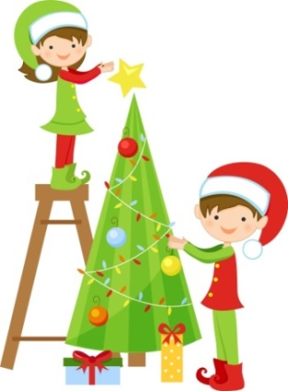
- VOLUNTEER: Many opportunities to help-- transform the gym into a winter wonderland or work the bazaar. See ministry scheduler to sign up.

Questions? E-mail DeCBazaar@gmail.com

Many hands make light work-- THANK YOU for your help and generous donations!!

